How to use service of distribute file server:

1. Run initservice.sh to initiate the service, load the database.
2. Put your files in the clientfiles folder

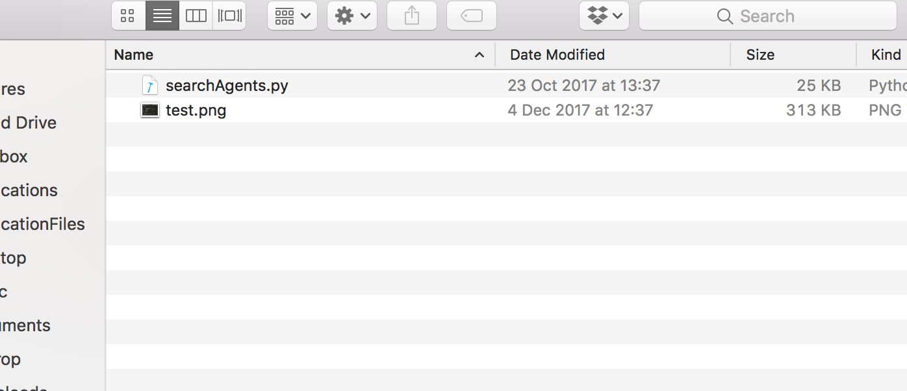

1. Open the client.py and input command and filename to upload or download files. You can create multiple clients to upload multiple files.

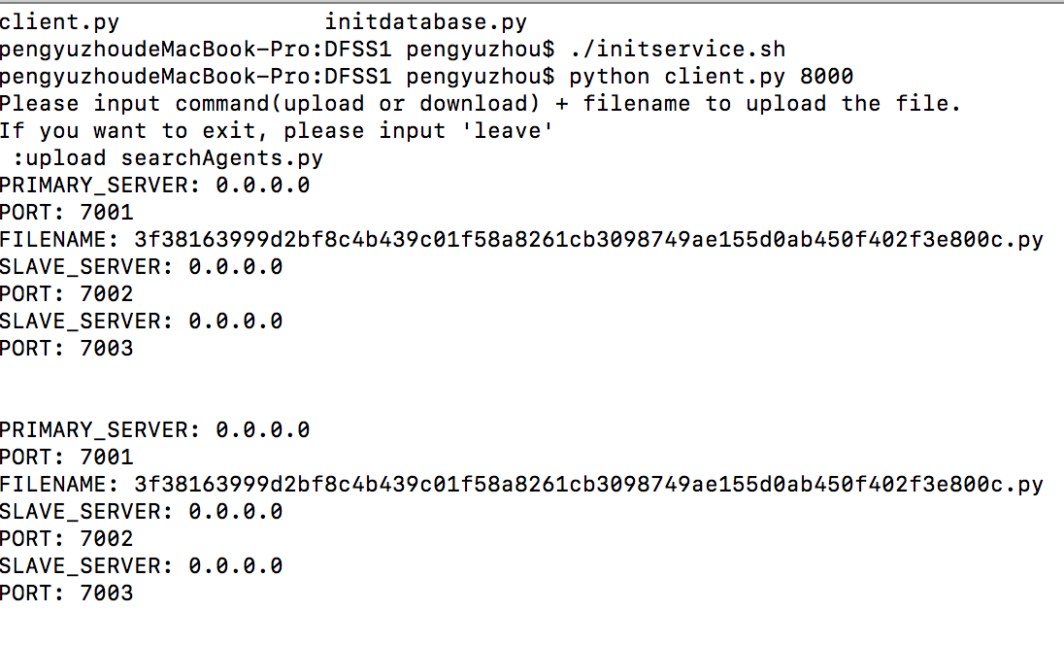

*upload files*

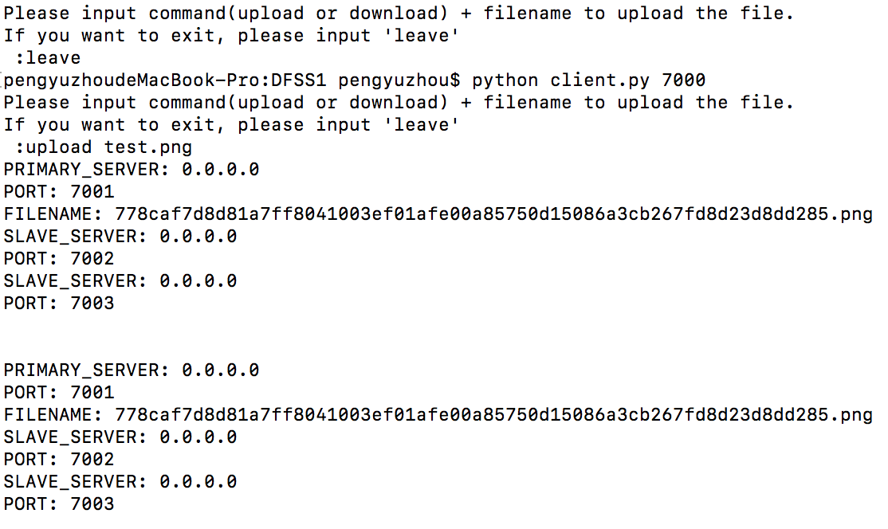

1. We then can see our upload files in our server files:

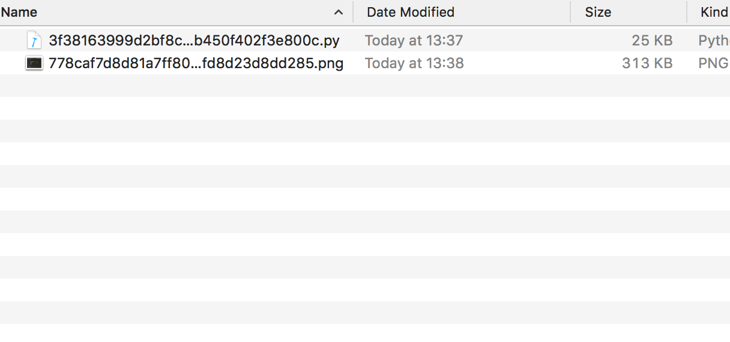

1. If you upload file to the primary node, then primary node will update duplicate file to all nodes.

